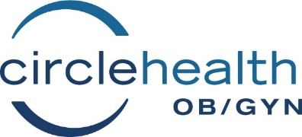
Policy information for patients regarding FMLA, PFML and Short-term disability forms
FMLA/PFML
Our medical records department is in charge of completing all FMLA/PFML and Short-term disability forms for your employer. In order to provide you with accurate information and speedy processing of your claims we ask your cooperation in providing the Medical Record department with complete and up to date information.
All forms submitted to us must include:
- Your full name
- Your Date of Birth
- Your email address
- Your signature and completion of your information on the form.

ALL FORMS ARE SUPPLIED BY YOUR EMPLOYER. Check with your Human Resource Department to obtain those forms. It is your responsibility to confirm your eligibility and know your specific employer policies regarding medical leave.
FMLA stands for Family Medical Leave Act. For those employers who are eligible for this program it provides up to 12 weeks of job protected unpaid leave in a calendar year. You may use these hours anytime during your pregnancy. FMLA paperwork will be completed within 2 weeks from date of submission. Please provide a fax number where the completed forms can be faxed to your employer.
PFML stands for Paid Family Medical Leave. PFML applies to Massachusetts employers. PFML provides up to 12 weeks of job protected, paid family leave starting after birth. This program provides flexibility in how you schedule your leave. PFML forms can only be completed after your date of delivery. Those are the requirements of this program. Any submissions prior to delivery will be denied. These completed forms will be emailed to you.
Both of these forms are to be submitted to us no sooner than 28-30 weeks of pregnancy
Short term disability applications must be approved by our office prior to submission. Medical disability requires documentation of a medical diagnosis preventing you from performing your job. Pregnancy itself it not a medical diagnosis.
There is a service fee to complete short-term disability forms of $10.00. It must be paid at the time the forms are submitted. We cannot accept cash or personal checks.
If there are any questions regarding completion of these forms please call our Medical Records Department at 978-256-1858 Extension #6.
For questions regarding Paid Family and Medical Leave (PFML) benefits, please log into the Department of Family and Medical Leave- Massachusetts at the following sites:
https://www.mass.gov/orgs/department-of-family-and-medical-leave
OR
https://www.mass.gov/info-details/paid-family-and-medical-leave-pfml-overview-and-benefits

Form A-10
01/2023

